Daniela Morales

Samantha Beckerman, 104

ESPM 50AC

6 December 2016

A Brief Visual History of San Francisco: ESPM 50AC Final Project

**San Francisco during Pre-Spanish Colonization:**

Environmental Breed

We are children of the earth,

Of the forest,

Of the sea.

Every morning I look across the water and I see a part of me.

A part that I did not know existed.

A part that I discover,

Every day a new.

I hope that when you look across the water

You can see it too.

It’s as if I weren’t human.

It’s as if I were a seed.

Growing,

Flowing,

Showing,

My new environmental breed.

The bay it does this to me.

As I feel the wind rush in.

I feel myself being pulled,

By every cell beneath my skin.

My brain it says don’t worry,

As my knees begin to shake.

I try to tell the ground,

“Please don’t begin to quake”.

I give myself a minute

Before I start to drown

In my tears of joy I cry

For this environmental town.

I chose to paint this map with earth tones to symbolize the environmental quality of the time. With the notations of the different Native American groups, subsistence methods, and ecosystems of the bay, I was able to create a different type of vision as to what San Francisco would have been like prior to Spanish colonization of the region. I included many land formations and bodies of water as well to provide an overview to natural aspects of the landscape—many of which we tend to take for granted in this technological era.

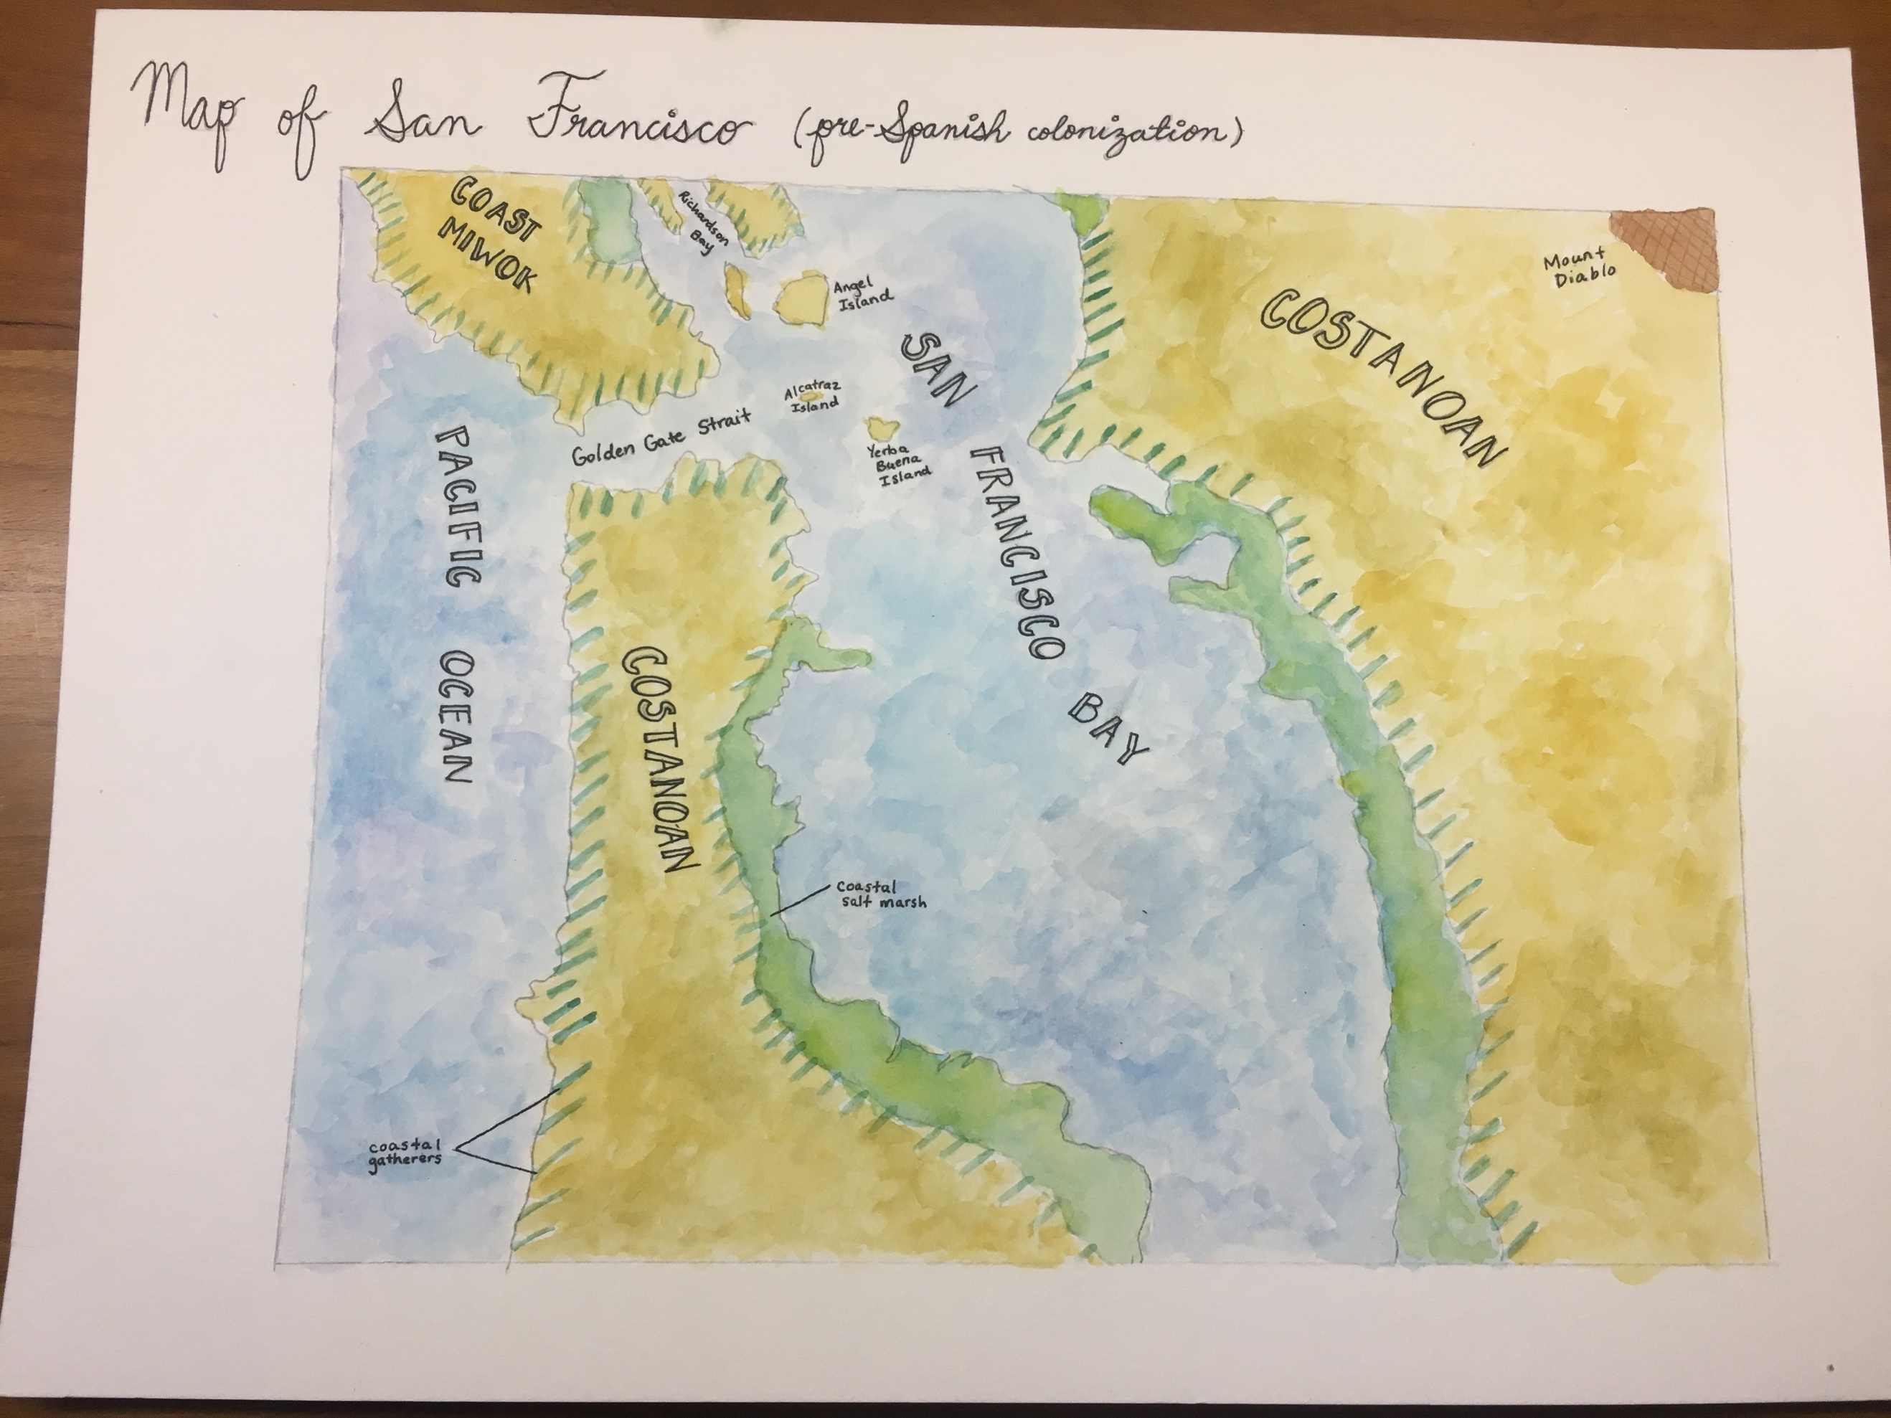

**San Francisco during Spanish Colonization Era:**

Ojos del Mar/Eyes of the Sea

Como te extraño mi niña bonita How I miss you my sweet

El mar me trae recuerdos de ti The sea brings me memories of you

El barco me recuerda a cuando bailamos The boat reminds me of us dancing

Y la brisa del mar a tus lagrimas And the sea breeze reminds me of your tears

Pero cuando pienso en ti But when I think of you

Me da una sonrisa I smile

Ya encontramos la bahia We have found the bay

Y el color del agua me recuerda a tus ojos And the color of the water reminds me of your eyes

Oigo a los alcatraces I hear the pelicans

Me recuerdan a tu risa They remind me of your laugh

Cuando llegue a la tierra When I get to land

Te voy a escribir una carta I am going to write you a letter

Describiendo este lugar tan hermoso Describing this beautiful place

Y el nombre que le di And the name I gave it

Por que mi recordo de ti Because it reminded me of you

San Francisco* te espera San Francisco* waits for you

Mi Paloma My Paloma*

*San Francis de Assisi is the Patron Saint of animals (Catholic Online)

*Paloma is a Spanish woman’s name, which translates to Dove

My goal for this map was to include the different cultural components of the Spanish colonization of San Francisco. For this reason, I painted the map in colors that were often seen in Spanish paintings of the 1500s—reds and yellows (often muted due to passage of time). This color scheme reflects the change from human interaction with nature being mainly benign, to the introduction of technology and chaos created by human institutions. I also included a drawing of a traditional Spanish ship similar to The San Carlos (the first ship to sail into San Francisco Bay), and an illustration of the Catholic Mission established in San Francisco, Mission San Francisco de Asis. Besides these aspects, I also provided Spanish names to all the landmarks as to set the scene for viewer. I wanted to provide a comprehensive and artistic view as to what the early Spanish settlement of San Francisco might have been comprised of.

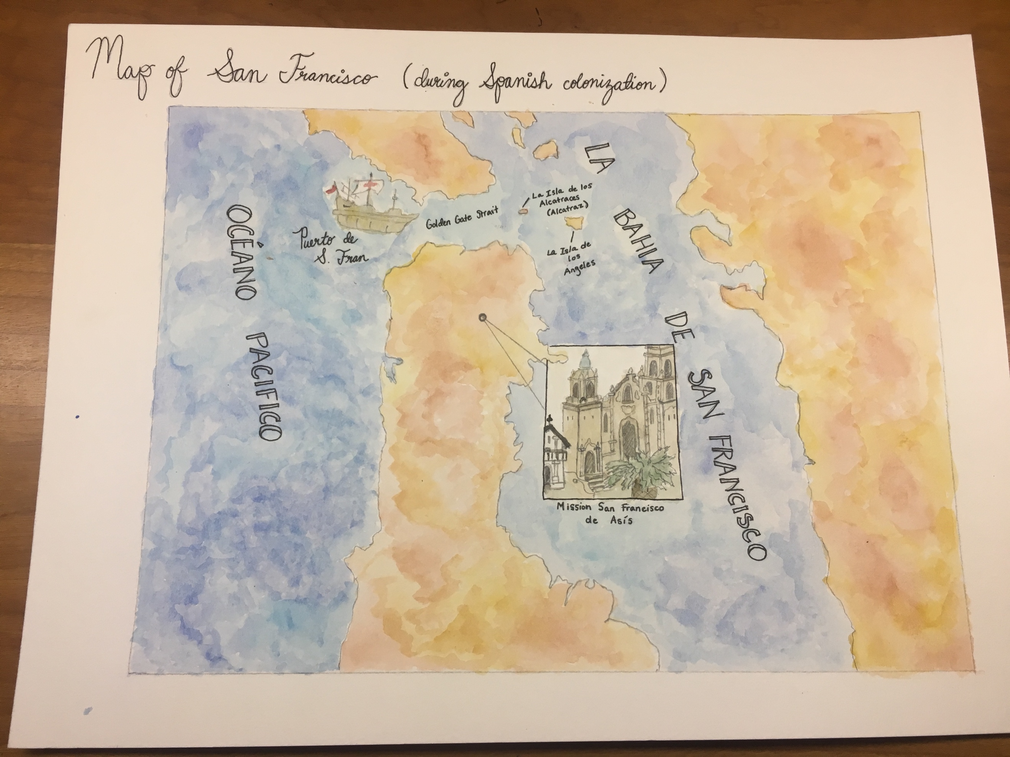

**San Francisco during Chinese Immigration and Earthquake of 1906:**

Paper Children in a Golden Town

I am a paper son travelling with another paper daughter.

We are merely cut outs of the world we left behind.

We do not exist outside of the new identities assigned to us,

By “family” which often does not come to mind.

Leaving the space we used to call our own

For one providing us with the opportunity to dream

Is not an easy thing to do

As contrary as that may seem.

The misfortune of others allows us to arrive.

But is it really a tragedy if it was not human error?

The chaos that the earthquake caused

Allowed us to navigate the immigration terror.

I just fear that this new world will not accept me

And soon my life will be nothing but rubble.

But that is something you face as a paper son or daughter:

A risk for something better that is often faced with trouble.

For this map, I made the color scheme a bit more vibrant to emphasize Chinese cultural tradition, which embraced deep, bright reds. I also tried emphasize through my choice in colors the chaos caused by the effects of the 1906 earthquake (San Francisco History-1900-1950). I made an attempt to translate the land formation names to simplified Chinese, putting extra importance on spaces such as the Pacific Ocean and Angel Island (which became an important location to Chinese immigration in the early 1900’s after the earthquake). I wanted to capture the disorder that the earthquake brought not only by destroying parts of the city such as Chinatown, but also by the influx of paper sons and daughters brought to San Francisco following the natural disaster (Barde). I hope this map both in the choice of color as well as language is able to emulate the socio-political feeling of the time.

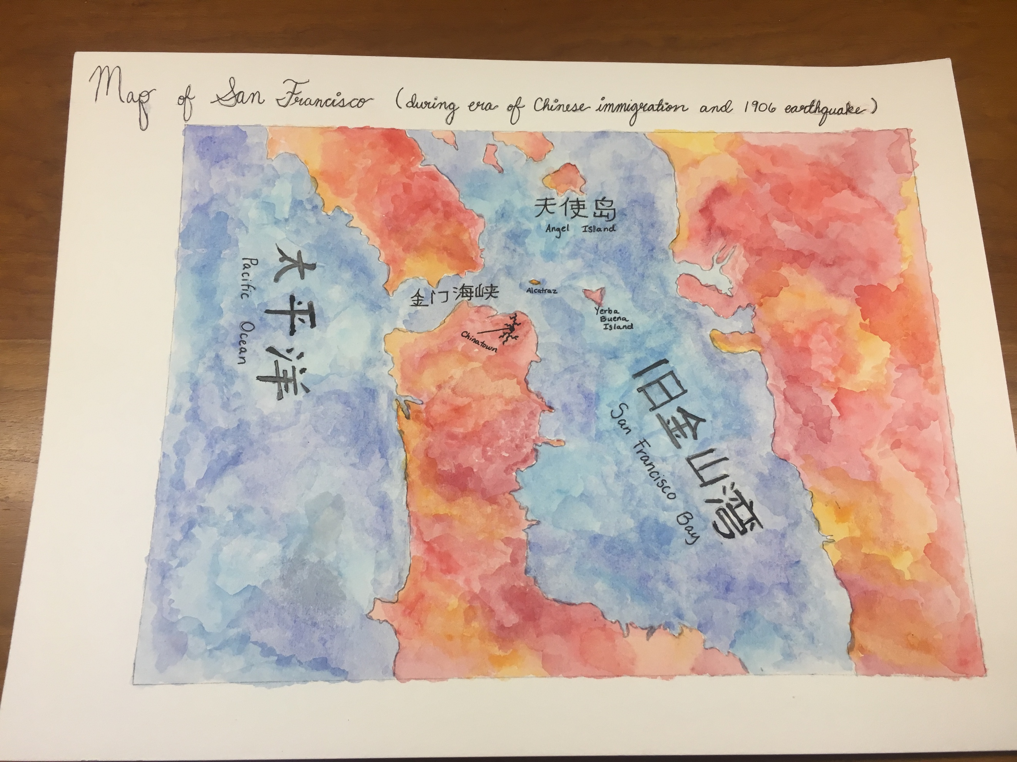**San Francisco during the 1930s:**

City of Bridges

A country in crisis.

Yet we industrialize.

Do we provide a template for what is to come?

Cities are growing.

Ours is no exception.

It is evident in the connection of physical spaces through bridges.

We expand.

We develop.

We innovate.

We become the new urban ideal.

Bridging the best of what we are,

People and nature,

That is how we grow, develop, and transform.

Regardless of the implications it may have on the entities we are try connect.

For this map I chose to go with a more natural color scheme despite the fact that the map is capturing an industrial and technological movement in San Francisco’s history. This choice is because the development of the city was externalized in the bridges constructed during this time (Fireman). I believe that this more neutral tome for the landscape also provides larger context to the situation taking place in the country. The United States was in the middle of the Great Depression, and was on the verge of a World War. Yet, San Francisco chose to implement infrastructure to develop the urban landscape. In the middle of the national crisis, San Francisco also established measures for cultural and social progress. I believe that this map encapsulates the dichotomy of the San Franciscan economy and focus on cultural advancement versus the concentration on other issues across the country during the 1930’s.

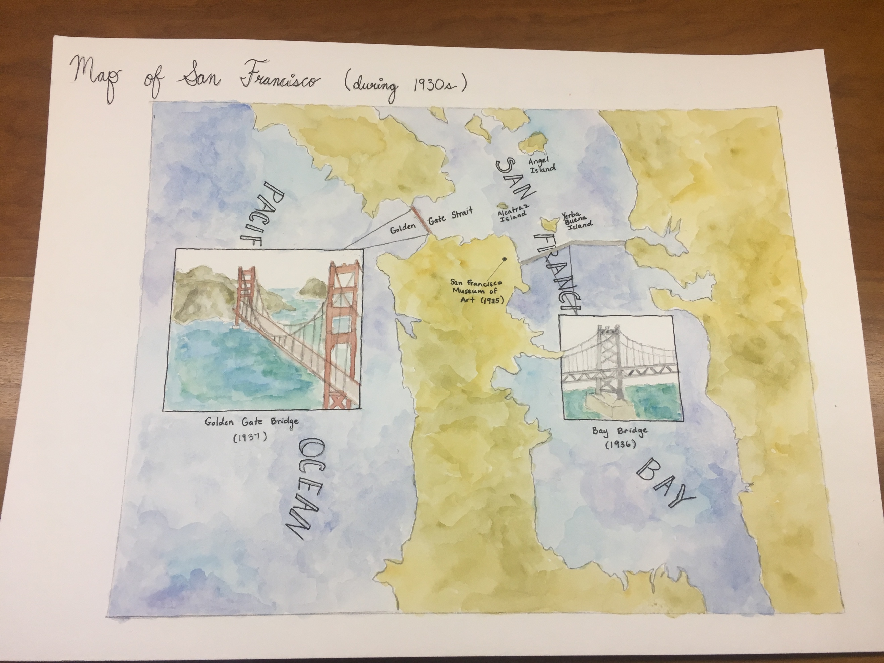**San Francisco Modern Day:**

One Day at a Time

I sit at a park as the cars buzz by.

My city has become nothing but a technological Mecca,

Where phones are worshiped, and skyscrapers rule.

How could we forget about our past so much,

That what comprised it ceased to exist?

What was once a lush landscape is

Overcome by the sound of cranes, and the smell of tar.

We grow.

We expand.

We develop.

But to what end?

What we once loved is gone,

And we’ve learned to love something that is beyond-human.

Machines have taken over.

Our natural world is fading.

Is there any way to keep it from disappearing completely?

I guess we’ll solve this issue one day at a time.

For this map I wanted to show the dichotomy between human impact and the natural environment. I did this by painting urban areas of San Francisco Bay red, to show the intensity of human manipulation of the landscape. I also went on to paint the areas that are built in land fill in orange to show that there was still a bit of human influence in how the land was augmented. And finally there are greenish-beige areas representing areas that are still semi-natural and unchanged. The water is also a bit bolder to show the disturbance created by transportation, pollution, and other human alterations. I really wanted to create an overwhelming and chaotic feeling to the map—a sentiment that is very much evident today in the dichotomy between the environment and people, and the uncertainty of environmental sustainability today. Through the use of color, intensity, and even messiness of the brush strokes I believe I was able to capture this idea of human recklessness and negligence towards the environment.

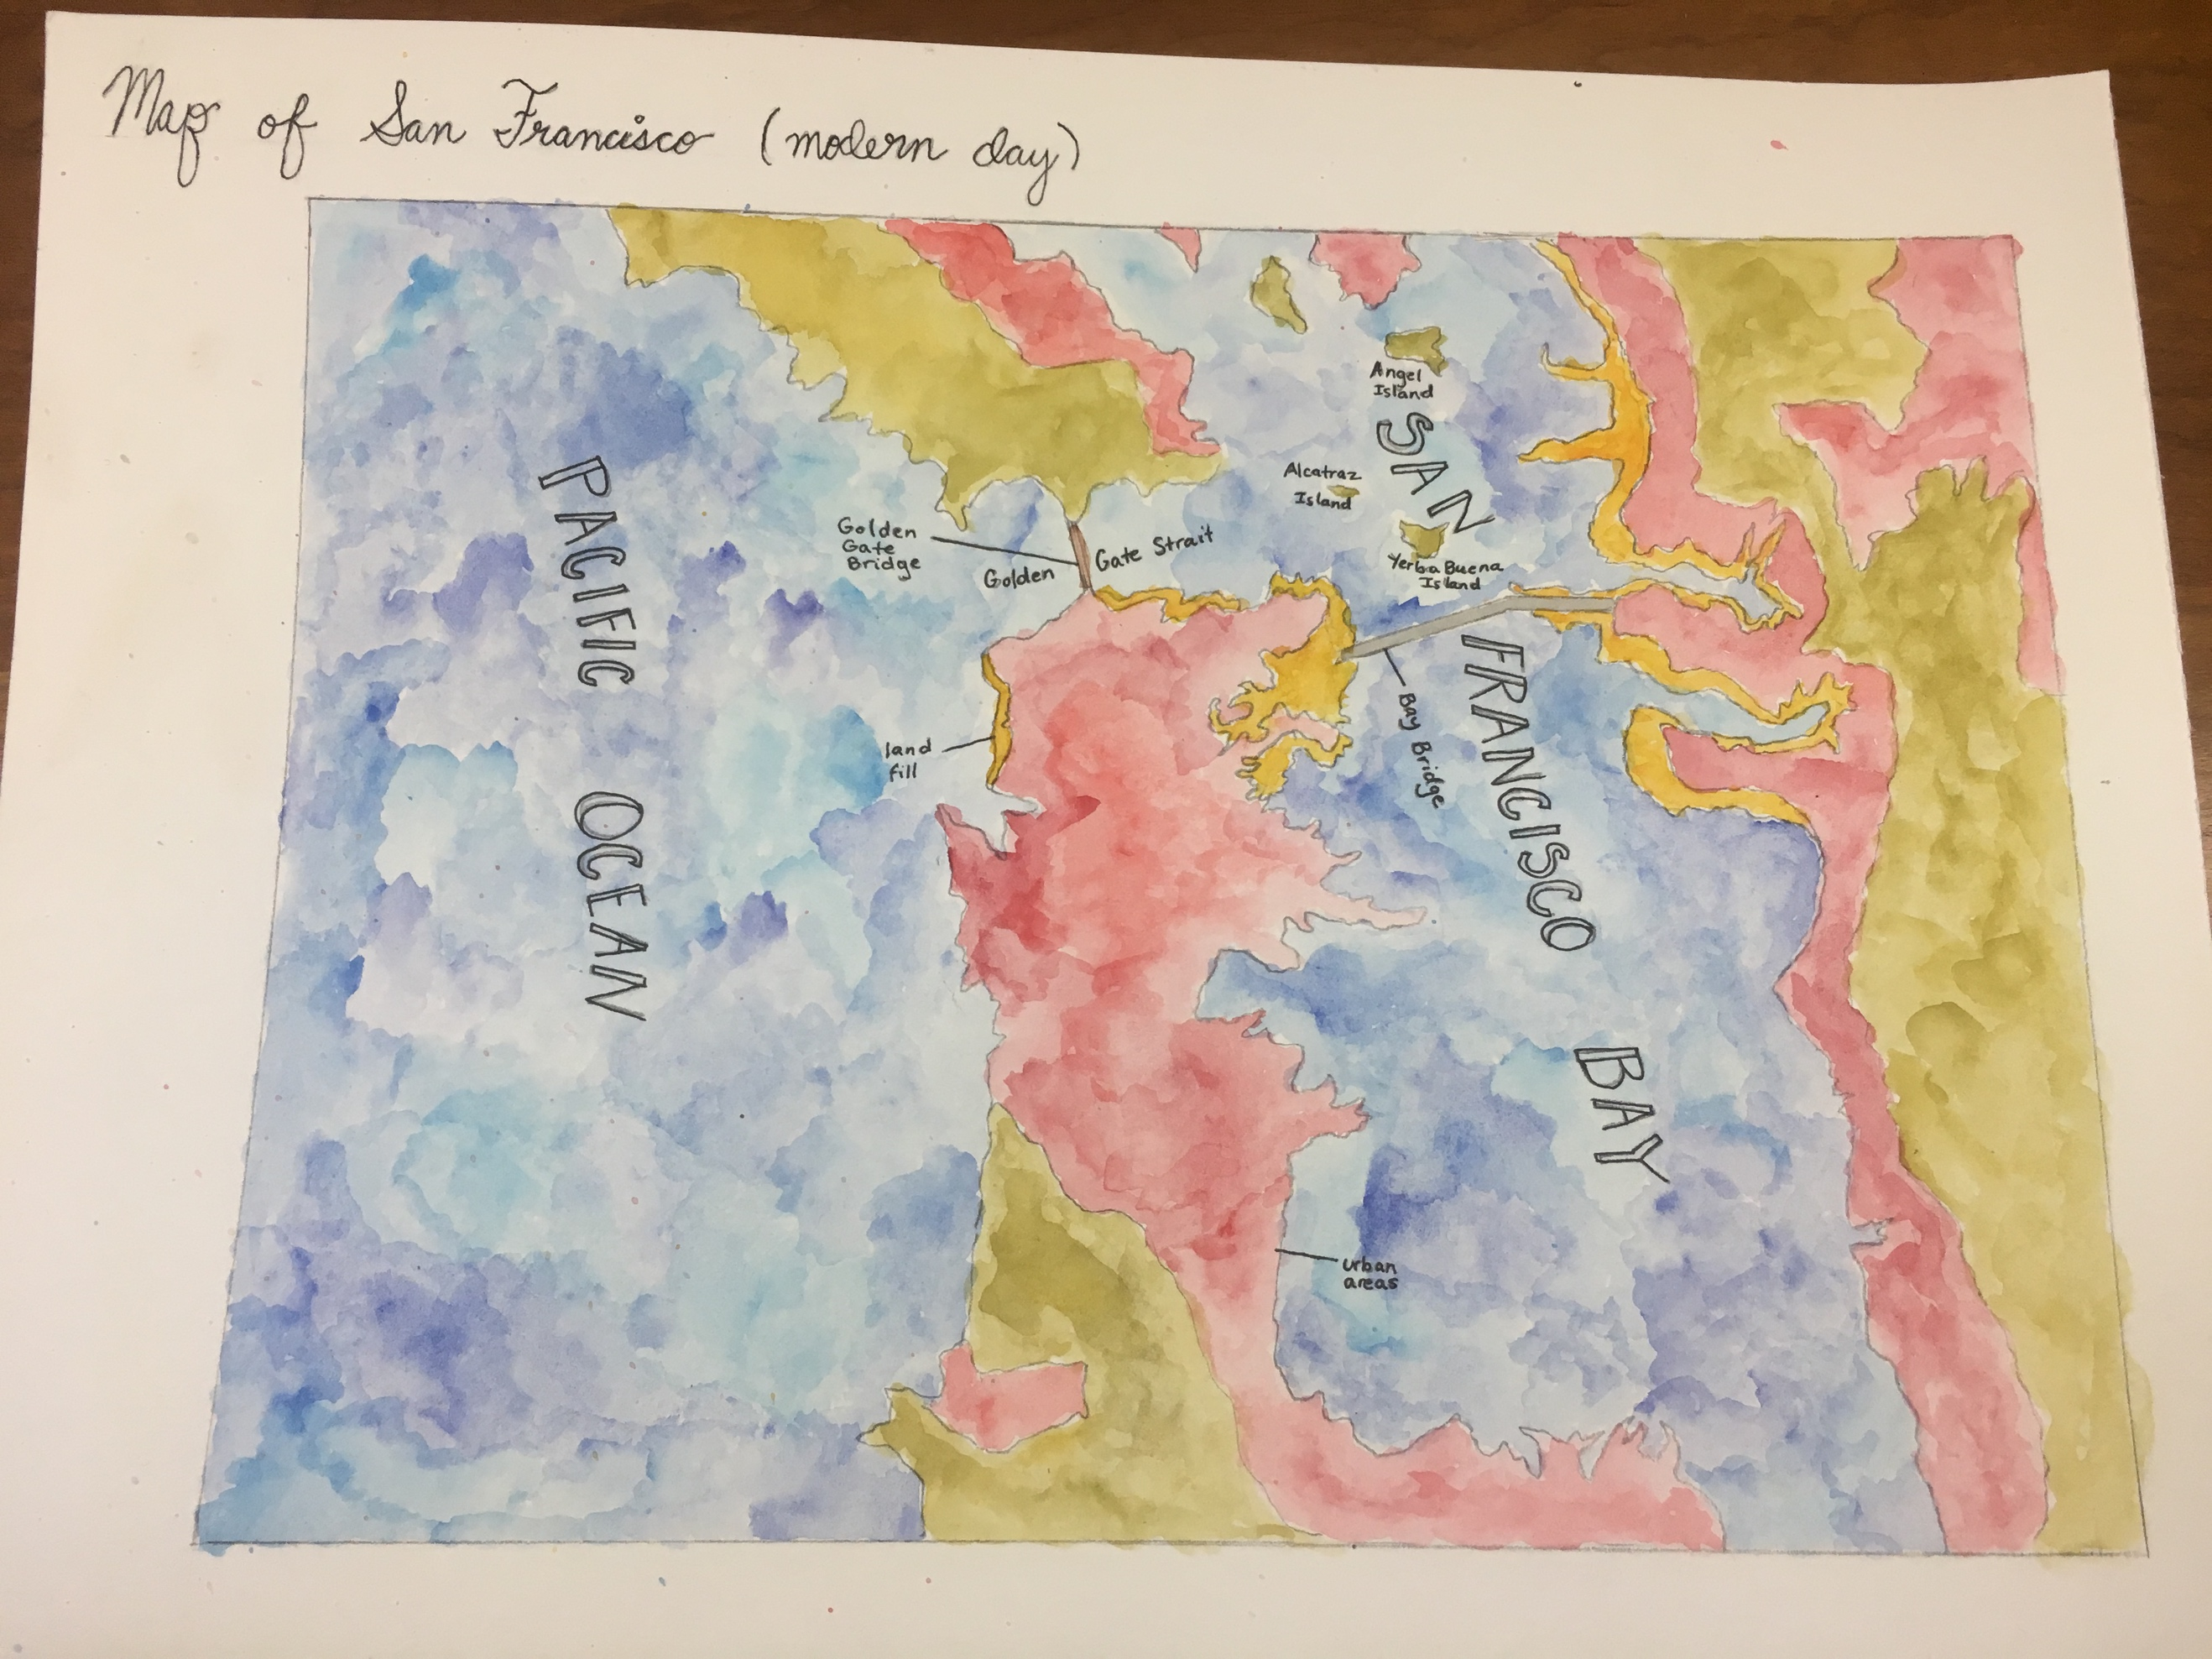

**Reflective Essay**

I chose to do Option nine for my final project because I needed an alternative to writing the standard three-page paper. I needed a distinct and interesting outlet by which to address what I learned in ESPM 50AC, and I knew the best way to do this was to incorporate my love for art and poetry into a social, environmental, and cultural project. I decided to construct maps of San Francisco from these different perspectives at five different points in history: Pre-Spanish Colonization, During Spanish Colonization, Era of Chinese Immigration and the 1906 Earthquake, During the 1930s, and Modern Day.

For the maps, I designed them with color and texture in mind, keeping to a specific color scheme throughout the project. The colors that I chose were reds, yellows, and beiges for the land, and a variety of different shades of blue for the sea. With these colors I tried to create a map that was dynamic and unique to each culture and time period. This required some research of the group of people that lived in the area, as well as the time period and certain events that occurred as well.

I faced several challenges while making the maps, one being spending too much time on one specific aspect of the maps and having a difficult time painting particular parts of the map as well. Drawing the maps consistently was a bit of an issue as well. I addressed my artistic challenges by accepting them. I realized that while this project was an academic assignment, it was also an opportunity to embrace the artistic objective of the project by allowing myself to find reflection and relaxation through this method of work. From this project I learned that there are outlets in which academic and artistic methods can intersect. Through my map making, I also learned more about the social, cultural, and environmental aspects of the San Francisco Bay Area. I believe that this project was the perfect way for me to not only communicate my interest in the intersectionality that exists between art and academics, but it allowed for the exposure of certain perspectives of the Bay area that are often lost in the crevices of history.

**Works Cited**

Barde, Robert Eric. *Immigration at the Golden Gate: Passenger Ships, Exclusion, and Angel Island*. Westport, CT: Praeger, 2008. Print.

Fireman, Janet, and Shelly Kale. *Bridging the Golden Gate: A Photo Essay*. 3rd ed. Vol. 89. San Francisco: California Historical Society, 2012. Print.

Online, Catholic. "St. Francis of Assisi." *Catholic Online*. N.p., n.d. Web. 06 Dec. 2016.

"San Francisco History - 1900-1950." *San Francisco History - 1900-1950*. N.p., n.d. Web. 06 Dec. 2016.

**Illustrations and Maps Which Influenced my Maps**

Bevk, Alex. "Old Maps of San Francisco Guaranteed to Blow Your Mind." *Curbed SF*. N.p., 18 Apr. 2014. Web. 06 Dec. 2016.

Hornbeck, David, David L. Fuller, and Phillip S. Kane. *California Patterns: A Geographical and Historical Atlas*. Palo Alto, CA: Mayfield Pub., 1983. Print.

Solnit, Rebecca, Ben Pease, and Shizue Siegel. *Infinite City: A San Francisco Atlas*. Berkeley, CA: U of California, 2010. Print.

"USGS Provides Long-Term Perspective for Integrated Science." *USGS Provides Long-Term Perspective for Integrated Science*. US Department of the Interior, 13 Dec. 2007. Web. 06 Dec. 2016.